**UNDER EMBARGO UNTIL 00:01 GMT on 25 March 2025**

**Become Your Own Remastering Engineer: Introducing the iFi iDSD Valkyrie**

***Southport, UK:*** iFi Audio, a trailblazer in high-fidelity audio components, proudly introduces its latest innovation: the iDSD Valkyrie. This flagship portable DAC/Amp is for those demanding more than pure power or precision; it’s for those who seek the power to shape their own sonic signature.

The Valkyrie fuses unrivalled customisation with cutting-edge technology, all in a compact form. It hides thunderous amounts of sonic control with K2HD Technology, DSD Remastering, six additional digital filters and iFi’s signature analogue processing. With quad-DAC architecture, 5,700mW* peak output, lossless Bluetooth, and 18-hour battery life, it is unmatched by any other portable on the market.

*\*Peak output measured using iFi’s standards. For more information, please visit: https://ifi-audio.com/faqs/how-maximum-power-is-measured/.*

**Key features & functionality:**

* **K2HD Technology:** Restores the richness of analogue sound, offering a natural listening experience.
* **DSD 1024 Remastering:** High-performance FPGA professionally remasters audio to DSD512 or DSD1024 for exceptional clarity and detail.
* **Quad DAC Architecture:** Four interleaved Burr-Brown DACs deliver the dynamics of famed multi-bit chipsets, with superior low-level linearity.
* **5,700mW Peak Output:** Delivers formidable power for driving the most demanding headphones.
* **Lossless Bluetooth and xMEMS Support:** Delivers CD-quality Bluetooth via aptX Lossless and next-gen driver compatibility for ultra-fast, precise sound.
* **20,000mAh Battery:** 18 hours of continuous playtime, with fast charging via USB-C in just 2.5 hours.

**Studio Secrets, Now Yours**

The iDSD Valkyrie isn’t just powerful, it’s personal. Designed for those who crave musicality and emotional depth, the Valkyrie takes tools once reserved for the world’s top mastering houses and delivers them directly to your fingertips, ready to be experienced at the press of a button.

**DSD 1024 Remastering**

Inspired by the artistry of mastering engineers, Valkyrie features a high-performance FPGA that allows for professional-grade remastering of PCM or DSD files, with the proprietary algorithm used being close to that of Sony’s mastering studios in Japan.

Users can choose between the ‘Normal’ setting, in which DSD signals pass directly to the DAC and PCM signals go through a user-selected digital filter, or ‘Remastering’, with options to remaster to DSD512 or DSD1024 - where some digital filters are still selectable with pre-modulation.  
   
DSD as a format inherently increases audio resolution and reduces distortion due to its high sampling rate, and DSD512 and DSD1024 can be thought of as equivalent to PCM signals at 704.8kHz/24-bit and 1.4MHz/24-bit, sampling that single bit of information 22.4 and 44.8 million times a second respectively - figures unachievable with native PCM. This allows a listener to truly experience their music catalogue, regardless of file type, in the highest possible quality.

**K2HD Technology**

At the heart of the Valkyrie lies JVCKENWOOD’s renowned K2HD Technology, designed to restore the warmth and emotion of analogue recordings - ensuring your digital audio never sounds cold or clinical. This technology is offered in two flavours: ‘K2’ mode preserves the file’s original resolution, while ‘K2HD’ optionally upscales it to 192kHz/24-bit.

Developed by JVC's engineers, K2HD Technology works to restore music close to its original master, infusing it with rich, natural harmonics lost during digitalisation. To achieve this, JVCKENWOODS’s engineers meticulously analysed countless analogue masters with K2HD restored sound by *ear* – shaping the algorithm solely on experience and feel. This is what separates the processing from others similar; due to the emphasis on human approach and feel, K2 has an innately organic quality unlike any other.

Over the years, the principle of K2 was adapted and applied to CD mastering, where high-frequency information above 22kHz is typically removed due to the 44.1kHz sampling rate, and resolution is reduced 256 times when the bit depth is lowered from 24-bit to 16-bit.

The iDSD Valkyrie applies K2 parameters specially tuned by JVCKENWOOD for iFi, focusing on time-domain processing to as opposed to frequency-domain adjustments. This approach allows for advanced high-frequency extension and minute signal (bit) extension, allowing both ‘K2’ and ‘K2HD’ modes to restore natural harmonics and overtones beyond 22kHz, and ultimately deliver audio that is closer to the original master recording.

**Find Your Sonic Signature**

With 8 digital filters and advanced analogue processing features like XBassII, XPresence and XSpace, the Valkyrie allows you to personalise your audio like never before.

Open-backs, while incredibly detail-rich and immersive, often have a trade-off where they are unable to match the low-end extension of closed-backs. Even certain closed-backs will roll off depending on the driver technology, size, and tuning. XBassII resolves this compromise through a pre-set low-end boost, complimenting most headphones without muddying the mid-bass or lower-midrange. This EQ is conducted through analogue circuitry, as this has enough headroom for a broad correction of frequencies without clipping or compromising dynamic range.

Additionally, there is a selectable ‘presence’ boost that lets users find their ideal midrange response. This midrange presence boost, aptly named ‘XPresence’, enhances the immediacy of sound, making it more forward and impactful for a larger-than-life presentation.

XSpace, found across various iFi products, enhances the audio by creating a spacious sound field, adding speaker-like depth to the more two-dimensional headphone experience. Crossfeed is a generalised term frequently used for such processing - and while it is true that XSpace does process the “difference” signal between left and right channels, it is not traditional Bauer/Linkwitz crossfeed, Meier enhanced crossfeed (or any of the other published systems based on the same research and targets).

XSpace is its own system, derived largely from the targets set by the Ministry of Radio and TV in East Berlin, and their foray into headphone/speaker replay compatibility; to allow a signal recording to playback via speakers or headphones, while retaining good spatiality. The results are distinct from and well in advance of “crossfeed” of all variants.

Outside of ‘K2’ mode and ‘K2HD’ mode, the Valkyrie includes six digital filters that are cyclable via the ‘filter’ button on the right of the fascia. Each trade off frequency response flatness, transient response and suppression of ultrasonic images in a different way:

1. **‘Bit–Perfect’** - No digital filtering is applied, one tap. This offers the best impulse response but loses high frequency extension.
2. **‘GTO’** - Minimal digital filtering - no pre-ringing, modest post-ringing, 32 taps. Proprietary filter aiming to be inaudible while attenuating unwanted ultrasonics.
3. **‘Apodising’** - Modest filtering, no pre-ringing, modest post-ringing, 128 taps. Aims to correct some of the impulse distortion during recording. Sound produced is fairly natural, with a slightly de-focused but enlarged sound stage, and correct HF detail.
4. **‘Transient Aligned’** - Max filtering, max pre-ringing, max post-ringing, 16,384 taps. Based on the theoretical, mathematical ‘ideal’ response and results in an enlarged sound stage and very smooth HF.
5. **‘Standard’** - Modest filtering, modest pre-ringing, modest post-ringing. It’s the typical FIR reconstruction filter used in many CD players and DACs. Results in a focused sound stage with controlled highs.
6. **‘Minimum’** - Minimum filtering, minimum pre-ringing, minimum post-ringing, 32 taps. Excellent compromise between Bit-Perfect and more complex filters, with a focused sound stage and correct HF detail.

**Quad DAC Architecture and Separated Circuitry**

The Valkyrie is built around a quad-stack of Burr-Brown DSD1973’s in a hybrid multi-bit configuration that guarantees exceptional audio precision, with a whisper quiet noise floor and excellent linearity.

iFi has become synonymous with this specific Burr-Brown chipset - and for good reason - as choosing the right DAC topology significantly affects the final sound. This configuration was chosen by iFi from their long-standing experience with the legendary Philips TDA1541A.

iFi love the dynamics and slam of the Philips TDA1541, especially when a high-definition signal is used, but multi-bit topology doesn’t have the low-level linearity of Delta-Sigma topology.

The chipsets used in the iDSD Valkyrie allow for the top 6 most significant bits to be processed in true multi-bit fashion, while the remaining lower bits are modulated to one-bit via an oversampling filter, giving the best of both worlds.

All signals to the DACs are re-clocked with the low-jitter Global Master Timing® derived master clock from the AMR DP-777 to deliver class-leading accuracy.

The iDSD Valkyrie utilises a twin mono design. This design choice boasts improved channel separation and reduced interference, due to the physical distance and separation between each channel’s components. Additionally, the Valkyrie also features separate analogue and digital circuitry to further prevent crosstalk, ensuring the highest level of sound purity.

**aptX Lossless Bluetooth**

Say goodbye to cable clutter, tangled wires and knotted cables, and hello to Lossless Bluetooth. With circuitry based around the latest flagship Qualcomm QCC518X series Bluetooth chipset, Valkyrie delivers CD-quality audio wirelessly via aptX Lossless and Hi-Res 96kHz/24-bit audio via LDAC.

‘CD quality’ refers to audio with quality of 44.1kHz/16-bit, with a bit rate of 1,411kbps. In favourable RF environments, it operates at a maximum bitrate of 1,200kbps and can losslessly encode and decode all 1,411kbps without losing data - almost like compressing a computer file with zip. In more busy environments, it intelligently scales back the bitrate to ensure no dropouts or audible glitches.

**Exceptional Power for Audiophiles**

Audiophiles no longer need to dream of their home system’s power and features on the road - the Valkyrie brings the power, comfort, and quality of a home setup with you wherever you go.

The Valkyrie delivers approximately 44% more power than iFi's flagship, multi-award-winning iDSD Diablo 2 when driving current-hungry 16Ω headphones, and up to a staggering 5,700mW peak output power – or 2,258mW RMS. The Valkyrie can therefore drive the hungriest of headphones all in a portable body, so you can take your premium audio set up with you, wherever you go.

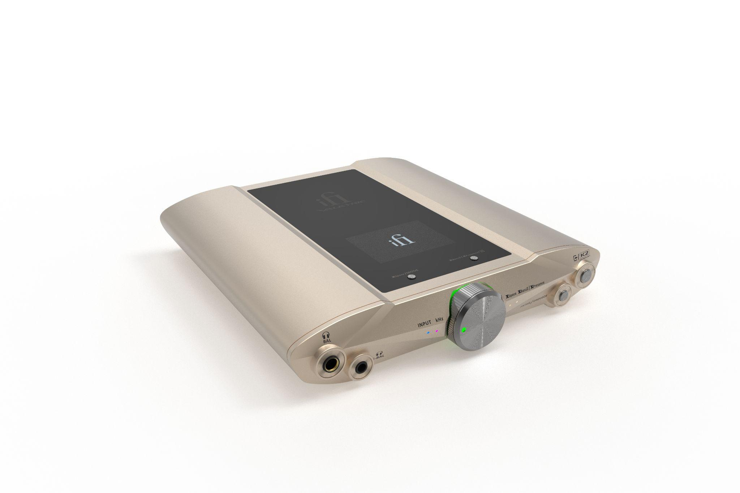

**xMEMS Support**

The iFi iDSD Valkyrie supports IEMs using xMEMS, an innovative speaker technology to push the boundaries of headphone performance.

xMEMS solid-state monolithic speaker technology produces the world’s fastest and most precise speakers for IEMs. These next-generation micro speakers boast a ~15 microsecond response time, 150 times faster than a typical dynamic driver.

This technology also allows for a flat phase response, with only 2 degrees of shift across the frequency range and 1 degree of phase matching (part-to-part) for more accurate sound reproduction and spatial reproduction respectively.

As xMEMS themselves say, “The inverse piezoelectric effect is created by applying electrical voltage to make the piezoMEMS contract or expand, converting electrical energy to mechanical energy. This energy excites an integrated silicon membrane to move air and generate acoustic sound waves… xMEMS’ piezoMEMs actuators offer an increased range of movement enabling rich, loud audio”.

As iFi were responsible for pioneering xMEMS amplification - first found in the iDSD Diablo-X - iFi have been able to develop (in collaboration with xMEMS) the optimal voltage and EQ needed for this cutting-edge technology. This equalisation features a low shelf, with an 8dB boost relative to 1kHz, with a slight lift of 1.5dB at 2kHz to enhance presence. The EQ is entirely passive, activating along with the -14V bias when a 4.4mm plug is inserted into the iDSD Valkyrie - making it safe to plug in normal IEMs without causing damage (though the sound quality will be affected).

**Colossal Capacity, Silent Stability**

With up to 18 hours of uninterrupted, crystal-clear playback on a single charge, the Valkyrie is built to power your most immersive and extended listening sessions. Rapid charging via USB-C takes from just 2.5 hours for a full charge.

Running the Valkyrie from batteries offers sound free from electrical interference and noise, wherever you listen. Under the chassis are four 5,000mAh, 21700-type lithium-ion batteries, totalling a colossal 20,000mAh.

**Pricing & Availability**

The iDSD Valkyrie is available to purchase from ifi-audio.com, or through our Elite dealers for £1,699/$1,699/€1,699.

**UK Press Contact**

**Ranieri Agency** - ifi@ranieri.agency

**About iFi**

iFi is the sister-brand of Abbingdon Music Research (AMR) and is headquartered in Southport, UK. The two brands respectively design and manufacture portable, desktop and lifestyle audio products and high-end hi-fi components. Combined in-house hardware and software development teams and a ‘music first’ approach enable iFi and AMR to create advanced audio products that deliver new levels of design, functionality and performance at their respective price points. Since iFi’s formation in 2012, its products have earned many awards around the world, helping it to become one of the fastest-growing brands in its field.

[www.ifi-audio.com](http://www.ifi-audio.com)

**General Specifications**

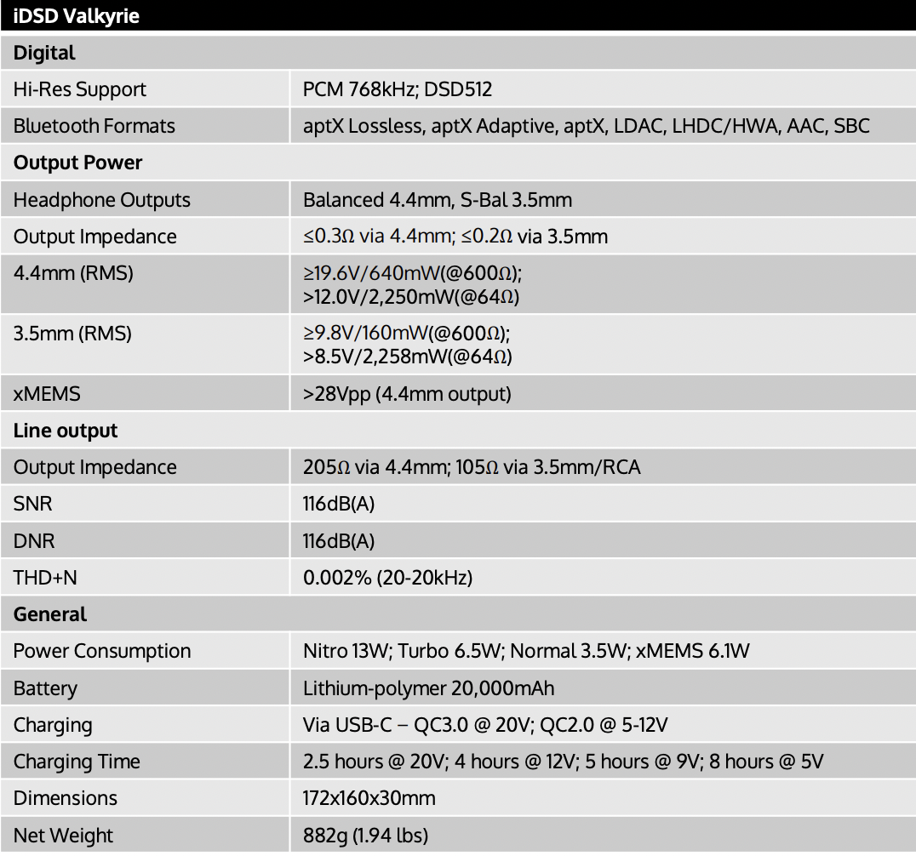

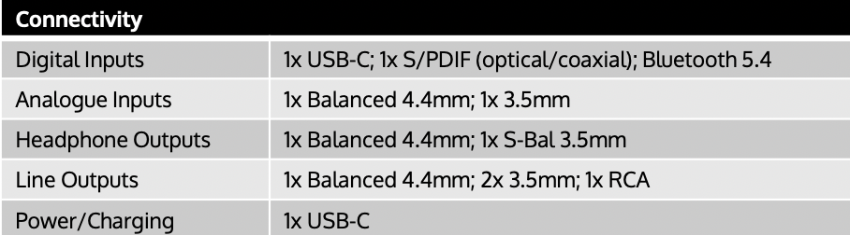

"K2 Technology" and "K2HD" are trademarks or registered trademarks of JVCKENWOOD Corporation. For more information, please visit https://www.jvckenwood.com/en/technology/k2.html